**Daily Scrum or Standup Meeting**

Team name: _____Team 04____________________

Scrum Master: __________Carter Figgins_____________

Date:__________10/16/2019_____________________

|  |  |  |  |
| --- | --- | --- | --- |
| **Team Member** | **What did you do since the last scrum?** | **What do you plan to do before the next scrum?** | **What obstacles do you have?** |
| Carter Figgins | Nothing | Work on the Login Screen, Menu for User and Admin, Join Auction Page, User Setting Page. | None |
| Brock Francom | Nothing | Getting the Item view page done | None |
| Waseca Hodson | Nothing | Set up the models section of the Django app. At least get all the fields listed and outlined, won’t necessarily link it to other pages in Django app. But will get database layout setup. | Researching more how Django does databases. |
| Sterling Tolley | Nothing | Work on application landing pages, basic design proposals and Auction creation and joining | Researching Django |
|  |  |  |  |

# Burndown

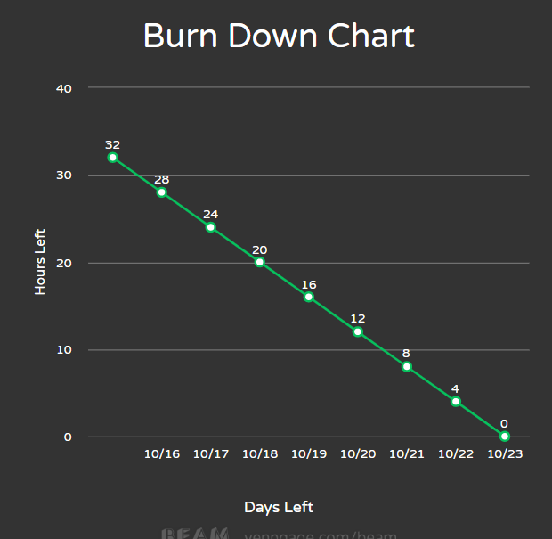

# Screenshot of you project board

